Tyler Holland
Spencer Ellsworth
CPE 349
Lab 6

Longest Common Substring
Here we have a graph showing the average run time of comparing a string to itself (p1avg) versus the size of the string and the average run time of comparing two random strings of equal length (p2avg) versus the size of the strings.
Note: The Run Time is in Millions of Nanoseconds.
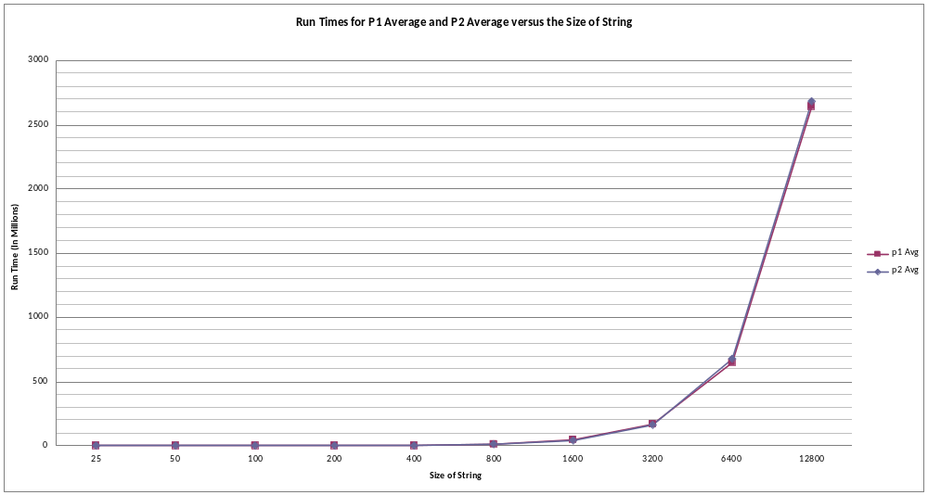

Additionally, we have here included the data collected, as the chart does not show much of a noticeable difference, but the difference is clear when viewed in the collected data.
Note: The Run Time is in Nanoseconds.
Size | p1 Avg | p2 Avg
25 | 71192 | 56127
50 | 44050 | 43476
100 | 172185 | 169195
200 | 853013 | 614225
400 | 2531567 | 2634642
800 | 9620734 | 12169480
1600 | 43813391 | 42692756
3200 | 167368841 | 164265317
6400 | 646083134 | 675335508
12800 | 2640330686 | 2684214908

We very quickly began to run out of stack heap space, so we increased the space (through Eclipse) to 1.5 gigabytes. At 1.5 GB of stack heap space, we were able to go up to strings of length 12800. At this size, we had hit our “serious limitation spot.” (As a side note, this was tested on a computer with an octicore processor and twelve gigabytes of RAM.)

Based on observations we made from the data we collected, it appears that there is very little difference between the length of time necessary to find an LCS of two random strings and the length of time necessary to find an LCS of a string with itself. However, there is a slight difference, and through this difference we observed that it mostly takes less time to find an LCS of two random strings.

